

**ASE Student Career Development**



**Mentor/Intern Training**

**COMBINED SESSION**

**Combined Session**

Here is the agenda for this afternoon’s training session:

* Intern and mentor introductions
* Internship expectations comparison
* Work journal and “homework” assignments
* Local school requirements/issues
* Measuring student progress

**Student and Mentor Introductions**

Introduce your partner to the group; students introduce their assigned mentor; mentors their assigned interns. In your introduction, include something about your partner that people don’t already know.

**EXERCISE: Introduction Notes**

|  |
| --- |
|  |
|  |
|  |
|  |
|  |
|  |
|  |
|  |
|  |
|  |
|  |
|  |
|  |
|  |
|  |

**Internship Expectations**

In separate sessions, both mentors and students developed a list of expectations for the summer internship. The students identified what they expected of their mentors, and the mentors identified what they expected of their students.

Compare your expectations with those of your partner.

**EXERCISE: Summer Internship Expectations** **Comparison**

|  |
| --- |
|  |
|  |
|  |
|  |
|  |
|  |
|  |
|  |
|  |
|  |
|  |
|  |
|  |
|  |
|  |

**Personal Styles**

Everyone has had a chance to think about and discuss personal interaction styles. We have pointed out that understanding personal styles can certainly improve relationships.

A good way to continue the “getting to know one another” process is to talk with one another about your personal style. Remember that the “true/false” stimulator exercise was only a way to get discussion started. Use examples from your own life to illustrate your personal style.

**The Student Work Journal**

Remember: the internship is first and foremost an extension of the educational experience that began in a classroom at your school. “Homework” is part of the package and it comes in the form of the *Work Journal*.

A review of the *Work Journal* components ensures that the expectations of both the student and the mentor are aligned, at least as far as paperwork responsibilities are concerned.

For students, the *Work Journal* provides a way for your teacher to see what you are doing and not doing on the job, and how some additional instruction may be called for at school. It’s also a way for your mentor to see what was or wasn’t done on a vehicle assigned to you for service.

The *Work Journal Diagnostic Reports* are an important, required part of your internship. It is your responsibility to fill one out for every vehicle you service.

Prior to the start of the internship, organize and create a work journal. Work with your teacher to understand his/her requirements for the work journal. This lesson sets out various tools that can be used to meet the fundamental elements of a good work journal. These are:

* Work Journal Diagnostic Report
* Skill Record Sheets
* Applied Education Summary

The work journal is a way for your teacher to monitor what kind of work assignments you are receiving and, as a result, what learning and experience you are or not getting in the workplace. Your teacher may have alternative tools that better fit his/her means of monitoring and evaluating advancement in the internship. Work with your mentor and teacher to understand the work journal requirements for your assignment.

A *Work Journal Diagnostic Report* is completed for each and every vehicle assigned. A copy of a properly completed Service Repair Order may be substituted, at the discretion of the automotive instructor and with the consent of the employer

If required, an *Applied Education Summary* assignment will be completed from one *Work Journal Diagnostic Report* each week.

*Skill Set Record Sheets* track the number of times your work assignments address certain tasks and are used by the automotive instructor or work-based learning coordinator to ensure workplace assignments meet the goals of the internship. 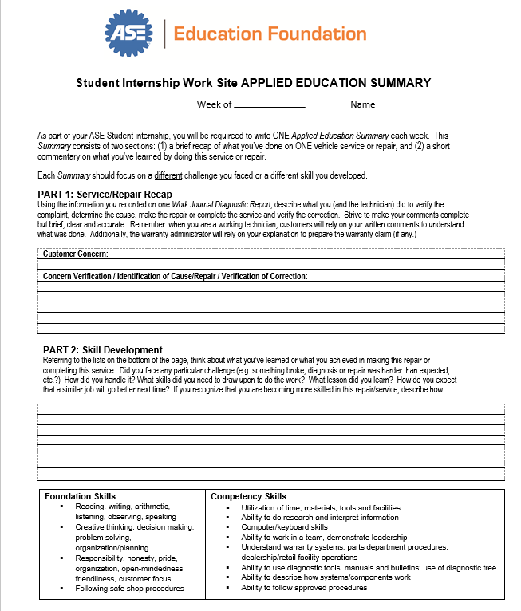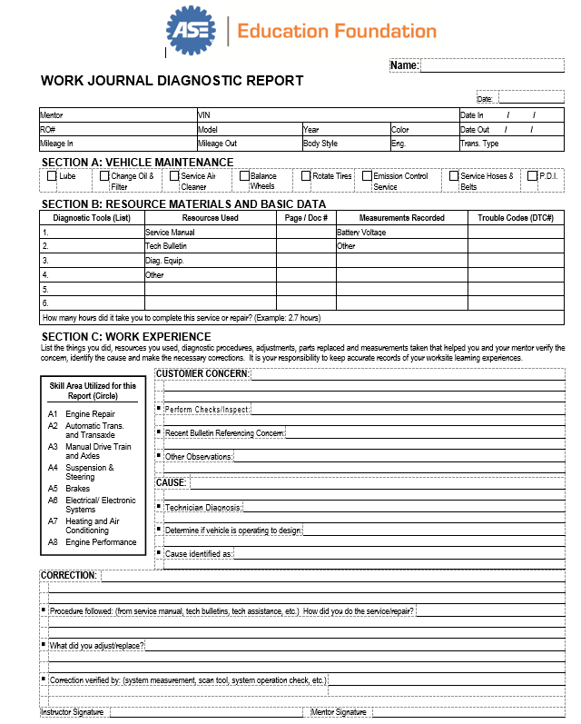

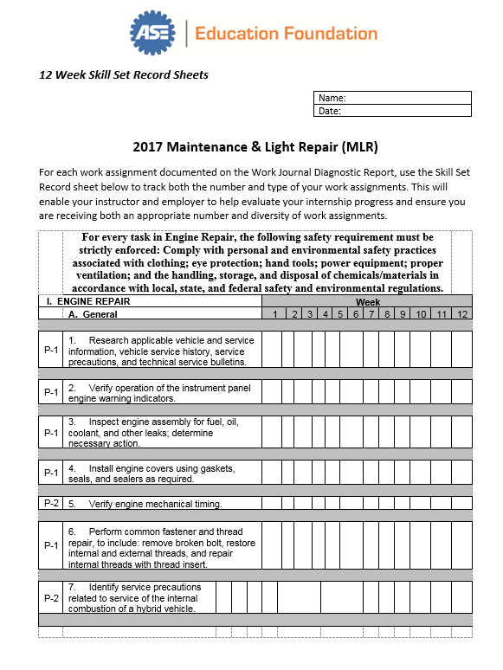

**Summary**

Here is a quick recap of this session:

* Intern and mentor introductions
* Internship expectations comparison
* Work journal and “homework” assignments.
* Local school requirements/issues.
* Measuring student progress

**NOTES**

|  |
| --- |
|  |
|  |
|  |
|  |
|  |
|  |
|  |
|  |
|  |
|  |
|  |
|  |
|  |
|  |
|  |
|  |
|  |
|  |
|  |
|  |
|  |
|  |
|  |
|  |
|  |
|  |