

**ASE Student Career Development**

**Mentor/Intern Training**

**WORK JOURNAL**

**Preparing for the Internship**

Remember: the internship is first and foremost an extension of the educational experience that began in a classroom at your school.

Prior to the start of the internship, organize and create a work journal. Work with your teacher to understand his/her requirements for the work journal. This lesson sets out various tools that can be used to meet the fundamental elements of a good work journal. These are:

* Work Journal Diagnostic Report
* The Applied Education Summary
* The Skill Record Sheets

The work journal is a way for your teacher to monitor what kind of work assignments you are receiving and, as a result, what learning and experience you are or not getting in the workplace. Your teacher may have alternative tools that better fit his/her means of monitoring and evaluating advancement in the internship. Work with your mentor and teacher to understand the work journal requirements for your assignment.

**The Work Journal**

The work journal:

* Is a communications tool – the permanent record of what service was performed on a vehicle and why it was performed.
* Is an evaluation tool – documentation of what you learn, practice and your progress.
* Is a development tool – fostering appropriate interaction with customers, factory representatives, service advisors, managers and other members of your team.
* Should be updated daily and always current
* Represents a portfolio of your professional progress.
* Helps fulfill your SkillsUSA requirements.

**Work Journal Diagnostic Reports**

You will be completing a Work Journal Diagnostic Report for each and every vehicle you work on. A copy of a properly completed Service Repair Order can be substituted or separate Work Journal Diagnostic Reports, at the discretion of your automotive teacher and with the consent of your employer

**Weekly Applied Education Summary**

If required by your teacher or school-to-work coordinator, you will select one Work Journal Diagnostic Report for that week and use it complete the Applied Education Summary assignment.

**Skill Set Record Sheets**

These record sheets are used to track the number of times your work assignments address certain tasks. Your teacher or school-to-work coordinators use these to ensure your work assignments meet the goals of the internship.



**WORK JOURNAL DIAGNOSTIC REPORT**

|  |  |
| --- | --- |
| Date: |  |

|  |  |  |  |  |
| --- | --- | --- | --- | --- |
| Mentor | VIN | | | Date In **/ /** |
| RO# | Model | Year | Color | Date Out **/ /** |
| Mileage In | Mileage Out | Body Style | Eng. | Trans. Type |

**SECTION A: VEHICLE MAINTENANCE**

|  |  |  |  |  |  |  |  |  |  |  |  |  |  |  |  |
| --- | --- | --- | --- | --- | --- | --- | --- | --- | --- | --- | --- | --- | --- | --- | --- |
|  | Lube |  | Change Oil & Filter |  | Service Air Cleaner |  | Balance Wheels |  | Rotate Tires |  | Emission Control Service |  | Service Hoses & Belts |  | P.D.I. |

**SECTION B: RESOURCE MATERIALS AND BASIC DATA**

|  |  |  |  |  |
| --- | --- | --- | --- | --- |
| **Diagnostic Tools (List)** | **Resources Used** | **Page / Doc #** | **Measurements Recorded** | **Trouble Codes (DTC#)** |
|  | Service Manual |  | Battery Voltage |  |
|  | Tech Bulletin |  | Other |  |
|  | Diag. Equip. |  |  |  |
|  | Other |  |  |  |
|  |  |  |  |  |
|  |  |  |  |  |
| How many hours did it take you to complete this service or repair? (Example: 2.7 hours) | | | | |

**SECTION C: WORK EXPERIENCE**

List the things you did, resources you used, diagnostic procedures, adjustments, parts replaced and measurements taken that helped you and your mentor verify the concern, identify the cause and make the necessary corrections. It is your responsibility to keep accurate records of your worksite learning experiences.

**Skill Areas Utilized for this Report (Circle)**

A1 Engine Repair

A2 Automatic Trans. and Transaxle

A3 Manual Drive Train and Axles

A4 Suspension & Steering

A5 Brakes

A6 Electrical/ Electronic Systems

A7 Heating and Air Conditioning

A8 Engine Performance

A9 Light Vehicle Diesel Engines

|  |  |  |  |  |  |  |  |
| --- | --- | --- | --- | --- | --- | --- | --- |
| **CUSTOMER CONCERN:** | | | | |  | | |
|  |  | | | | | | |
|  |  | | | | | | |
|  | Perform Checks/Inspect: | | | |  | | |
|  |  | | | | | | |
|  | Recent Bulletin Referencing Concern: | | | | |  | |
|  |  | | | | | | |
|  | Other Observations: | |  | | | | |
|  |  | | | | | | |
|  |  |  | | | | | |
| **CAUSE:** | |  | | | | | |
|  |  | | | | | | |
|  | Technician Diagnosis: | | |  | | | |
|  |  | | | | | | |
|  | Determine if vehicle is operating to design: | | | | | |  |
|  |  | | | | | | |
|  | Cause identified as: | |  | | | | |
|  |  | | | | | | |

|  |  |  |  |  |  |
| --- | --- | --- | --- | --- | --- |
| **CORRECTION:** | |  | | | |
|  |  | | | | |
|  | Procedure followed: (from service manual, tech bulletins, tech assistance, etc.) How did you do the service/repair? | | | |  |
|  |  | | | | |
|  | What did you adjust/replace? | |  | | |
|  |  | | | | |
|  |  | | | | |
|  | Correction verified by: (system measurement, scan tool, system operation check, etc.) | | |  | |
|  |  | | | | |

|  |  |  |  |  |
| --- | --- | --- | --- | --- |
| Instructor Signature |  |  | Mentor Signature |  |



|  |  |
| --- | --- |
| **Name:** |  |

**WORK JOURNAL DIAGNOSTIC REPORT**

|  |  |
| --- | --- |
| Date: |  |

|  |  |  |  |  |
| --- | --- | --- | --- | --- |
| Mentor | VIN | | | Date In **/ /** |
| RO# | Model | Year | Color | Date Out **/ /** |
| Mileage In | Mileage Out | Body Style | Eng. | Trans. Type |

The top section of the Work Journal Diagnostic Report contains information identifying the vehicle and general information about the service or repair.

In the upper right-hand corner enter your name and the date the Work Journal Diagnostic Report was completed. Then, starting from the top left corner and proceeding to the right and down enter:

* **Mentor** – the name of the person(s) who mentored the intern on this repair.
* **VIN** – the Vehicle Identification Number.
* **Date** **In** – the date the vehicle was presented for this service or repair.
* **RO#** – the repair order number for this service or repair.
* Model – include the make and model (e.g. Toyota Camry, Buick Enclave, etc.) of the vehicle being serviced.
* **Year** – the model year of the vehicle being serviced.
* **Color** – the color of the vehicle being serviced.
* **Date** **Out** – the date the service or repair has been completed and verified.
* **Mileage** **In** – the odometer reading of the vehicle on the date it is presented for service.
* **Mileage** **Out** – the odometer reading of the vehicle on the date the service or repair has been completed and verified.
* **Body** **Style** – 4-dr., SUV, Conv[ertible], etc.
* **Eng** – the engine size or family (e.g. 2.0 L).
* **Trans** **Type** – transmission type (8-spd. O.D., etc.).

**SECTION A: VEHICLE MAINTENANCE**

|  |  |  |  |  |  |  |  |  |  |  |  |  |  |  |  |
| --- | --- | --- | --- | --- | --- | --- | --- | --- | --- | --- | --- | --- | --- | --- | --- |
|  | Lube |  | Change Oil & Filter |  | Service Air Cleaner |  | Balance Wheels |  | Rotate Tires |  | Emission Control Service |  | Service Hoses & Belts |  | P.D.I. |

**Section A: Vehicle Maintenance**

This section identifies common regular maintenance services requested by the customer. They are grouped together here for convenience.

**SECTION B: RESOURCE MATERIALS AND BASIC DATA**

|  |  |  |  |  |
| --- | --- | --- | --- | --- |
| **Diagnostic Tools (List)** | **Resources Used** | **Page / Doc #** | **Measurements Recorded** | **Trouble Codes (DTC#)** |
|  | Service Manual |  | Battery Voltage |  |
|  | Tech Bulletin |  | Other |  |
|  | Diag. Equip. |  |  |  |
|  | Other |  |  |  |
|  |  |  |  |  |
|  |  |  |  |  |
| How many hours did it take you to complete this service or repair? (Example: 2.7 hours) | | | | |

**Section B: Resource Materials and Basic Data**

In this section you will record information on the kinds or resource materials you used to perform the indicated repairs and any measurements taken in the diagnosis and repair process.

In the first column to the left, note the type(s) of diagnostic tools you used in performing the repair. Include scan tools (e.g. Solus, DRBIII, etc.), measuring tools and meters (DVOM etc.).

In the second column identify the service information source(s) used during this service/repair. Include online (e.g. Alldata, GMSI, etc.) as well as printed resources.

In the third column, record the specific page numbers, where applicable. This information can be valuable for future reference.

Record any measurements taken in the next column, Measurements Recorded.

Record any diagnostic trouble codes (DTC) found, in the column to the far right.

Finally, when the service/repair has been completed and verified, enter the total amount of clock time, in hours and tenths, it took you to complete this repair.

**SECTION C: WORK EXPERIENCE**

List the things you did, resources you used, diagnostic procedures, adjustments, parts replaced and measurements taken that helped you and your mentor verify the concern, identify the cause and make the necessary corrections. It is your responsibility to keep accurate records of your worksite learning experiences.

**Skill Areas Utilized for this Report (Circle)**

A1 Engine Repair

A2 Automatic Trans. and Transaxle

A3 Manual Drive Train and Axles

A4 Suspension & Steering

A5 Brakes

A6 Electrical/ Electronic Systems

A7 Heating and Air Conditioning

A8 Engine Performance

A9 Light Vehicle Diesel Engines

|  |  |  |  |  |  |  |  |  |
| --- | --- | --- | --- | --- | --- | --- | --- | --- |
| **CUSTOMER CONCERN:** | | | | |  | | | |
|  |  | | | | | |  | |
|  |  | | | | | |  | |
|  | Perform Checks/Inspect: | | | |  | | | |
|  |  | | | | | |  | |
|  | Recent Bulletin Referencing Concern: | | | | |  | | |
|  |  | | | | | |  | |
|  | Other Observations: | |  | | | | | |
|  |  | | | | | |  | |
|  |  |  | | | | | | |
| **CAUSE:** | |  | | | | | | |
|  |  | | | | | |  | |
|  | Technician Diagnosis: | | |  | | | | |
|  |  | | | | | |  | |
|  | Determine if vehicle is operating to design: | | | | | | |  |
|  |  | | | | | | |  |
|  | Cause identified as: | |  | | | | | |
|  |  | | | | | |  | |

|  |  |  |  |  |  |  |
| --- | --- | --- | --- | --- | --- | --- |
| **CORRECTION:** | |  | | | | |
|  |  | | |  | | |
|  |  | | |  | | |
|  | Procedure followed: (from service manual, tech bulletins, tech assistance, etc.) How did you do the service/repair? | | | | |  |
|  |  | | | | |  |
|  |  | | | | |  |
|  | What did you adjust/replace? | |  | | | |
|  |  | | |  | | |
|  |  | | |  | | |
|  |  | | |  | | |
|  | Correction verified by: (system measurement, scan tool, system operation check, etc.) | | | |  | |
|  |  | | | |  | |
|  |  | | | |  | |

|  |  |  |  |  |
| --- | --- | --- | --- | --- |
| Instructor Signature |  |  | Mentor Signature |  |

**Section C: Work Experience**

Arguably the most important elements of the repair process, this section records the customer concern, reports the results of the diagnosis activities, and describes the repairs made to correct the underlying (root) problem; the three Cs – Concern, Cause and Correction.

Not only does this fully justify the repair to the customer, it becomes part of the vehicle service history, and in many jurisdictions, is included by reference in the repair contract between the vehicle owner and the service outlet. For these reasons, it is important to be precise, concise and complete. Your mentor will be a valuable resource as you go through this as you complete this section.

**Customer Concern** – or complaint is what the customer reports to the service advisor as the reason for presenting the vehicle for service. Your first responsibility to this repair is to verify the customer complaint. There are three additional “bullet point” under this heading to help guide you.

* Perform Checks / Inspect – briefly describe what you observed in verifying the customer concern.
* Recent Bulletins Referencing Concern – is there a known pattern of similar concerns among similar vehicles?
* Other Observations – di you need to retrieve/research additional information from the service advisor or customer? Or did you notice something else that might have lead to the this concern? Note it here.

**Cause** – this is where you document your fact-finding that leads to your determination about the reason at the root of the problem presented in the customer’s concern. This could include:

* Technician Diagnosis – outline the steps of the diagnosis process used in pinpointing the problem. This could include inspections, measurements, wear patterns, etc.
* Determine if vehicle is operating to design – this could be a simple yes or no answer. However if not operating to specifications, you may add notes or comments.
* Cause identified as – be specific and tie your findings back to the customer concern.

**Correction** – here you describe the method, procedure or process used to repair the problem and verify that it addresses the customer concern.

* Procedure followed – from the service information referenced during the repair (e.g. service manual, TSB, etc.)
* What did you adjust/replace – identify the part or parts replaced adjusted or rebuilt.
* Correction verified by – include the method(s) used to verify the customer concern is fully addressed.

Finally, in the box labeled, ‘Skill Areas Utilized for this Report,’ on the left side of the form, it is recommended that you circle the vehicle systems area(s) covering the repairs made. This can a useful reference later when you complete the Skill Set Record Sheets.

You immediately can see how much information needs to be captured and recorded on the repair. This documentation becomes part of the vehicle service history. Regardless of whether you complete the Work Journal Diagnostic Report for each assignment, or use the service Repair Order, directly, the requirements are the same.

Space is provided at the bottom of the Work Journal Diagnostic Report for your mentor and instructor to review and “sign off” on your work assignments.

**EXERCISE: Practice Work Journal Entry**

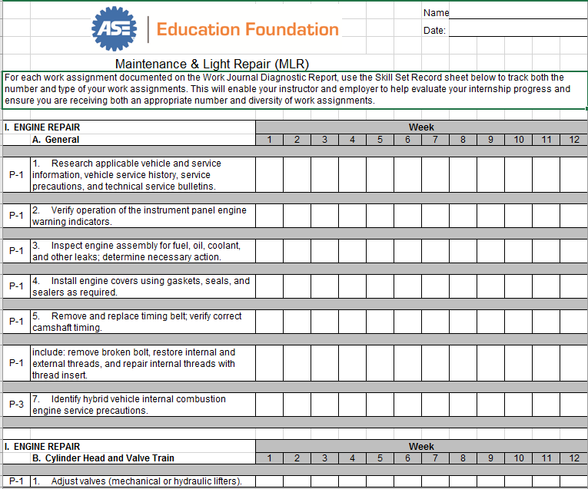

**Skill Set Record Sheets**

The Skill Set Record Sheets provide a top-level method to summarize your work assignments and enable your instructor, mentor and employer the means to evaluate your progress and/or ensure that you are receiving an appropriate number and diversity of assignments to develop your skills and augment your automotive technology education in the classroom.

On the previous page is an example of how the *Skill Set Record Sheets* might look when you fill them out. Blanks of these forms available on the ASE Education Foundation website ([www.ASEeducationfoundation.org](http://www.ASEeducationfoundation.org)).

At the end of each week, you will have completed a number of *Work Journal Diagnostic Report*s or service Repair Orders. You will have performed one or more of the many tasks defined in the nine Automobile, Collision Repair/Refinish, or M/H Truck skill areas.

At the end of the week, as you review your stack of *Work Journal Diagnostic Report*s or service Repair Orders, record the number of times you completed specific tasks during the week on the appropriate *Skill Set Sheet*. Keep in mind that one repair might cover more than one skill area or more than one task in any skill area.

For example, say the customer concern was an anti-lock brake light that stayed “on.” The repair included tasks in both the Electrical and Brake specialty areas and therefore should be counted in both areas.

To the left of each task in the Skill Set Record Sheet, you will notice a P-1, P-2, or P-3 designation. This refers to a priority ranking of the importance of learning particular tasks. It’s not likely you will be getting experience in every task in a specialty area. But this ranking system helps you, your mentor, and your teacher to make sure that you are getting experience in the most important areas.

It’s up to you to decide if it’s easier just to put a “hash mark” in the appropriate box for each *Diagnostic Report* or to count the number of *Diagnostic Reports* with that task recorded, and just write a number in the box.

**Why is it important to record these repetitions?**

The *Skill Set Record Sheet* helps you, your instructor or school-to-work coordinator, and your mentor see the repair areas in which you are getting the most number of job assignments, or work experience

If some related areas are blank or have low numbers it may be an indicator that you are not enough of some types of experience.

Taken together the Work Journal – the Work Journal Diagnostic Reports and Skill Set Record Sheets – become the detailed documentation of your work site learning experience and the basis for your evaluation.

**Applied Education Summary**

Now we come to the third part of your *Work Journal,* if assigned by your instructor or work-based learning coordinator – the *Applied Education Summary*.

Look at the example shown on the next page.

Repair documentation is becoming increasingly important. Not only is this the primary communication link to the customer, it is the basis of the permanent vehicle service history and part of the contract between the service provider – your employer – and the customer. To be **clear**, **complete** and **concise** in this regard is often what sets apart the best technicians from the rest of the technicians. You need to be able to communicate, in writing, what you observed, what you did, and why you did it.

Writing well is a skill, and like any skill, you need practice if you hope to get better at it. This is the purpose of the *Applied Education Summary*.

If the *Applied Education Summary* assignment is required by your instructor, choose one *Work Journal Diagnostic Report* or service Repair Order each week as a basis for this assignment. We suggest that you select one where you feel you really learned something valuable, found a particularly interesting problem or solution, or an where you were able to make an important contribution to getting the repair done.

Follow the directions that are on the form itself and write two paragraphs or so about that one repair.

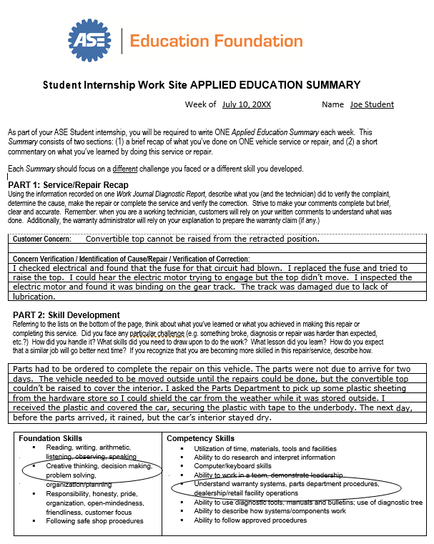

Refer to the example provided; in **Part 1**: Service/Repair Recap describe how you performed the diagnosis, your findings and how you made the repair.

In **Part 2:** Skill Development, write a few sentences about what made this assignment interesting, the particular challenges you encountered, or other special aspects of the assignment that made it of interest to you.

At the bottom of the page, draw a circle around the skills that this repair helped you to develop.

You may find it helpful to ask your mentor, work-based learning coordinator, or instructor to advise you on what you should include.

These paragraphs don’t have to be very long. In fact, take the opportunity to be both brief and complete. Strive to make your writing as clear as possible.

Don’t be discouraged if you have a hard time at first completing this *Summary*. Like anything else, it will get easier after you practice it a few times.

**NOTES**

|  |
| --- |
|  |
|  |
|  |
|  |
|  |
|  |
|  |
|  |
|  |
|  |
|  |
|  |
|  |
|  |
|  |
|  |
|  |
|  |
|  |
|  |
|  |
|  |
|  |
|  |
|  |
|  |
|  |