**2025 ASE Instructor Training Conference: Sample Justification Letter**

Dear <Supervisor’s Name>,

I am requesting approval to attend the 2025 ASE Instructor Training Conference July 21-24, 2025, in St. Louis, Missouri. The conference is presented by the ASE Education Foundation, a non-profit organization that provides accreditation for secondary and post-secondary automobile, truck/diesel, and collision repair programs based on industry-developed standards. The 2025 ASE Instructor Training Conference is the premier national training event focused specifically on the technical training needs of automotive instructors.

At this event I will:

* Have access to 20+ hours of technical update training aligned to my program specialty,
* Connect with other professionals in my role from across the country, as well as industry and workforce experts with knowledge of the latest automotive technology and training trends,
* Learn from other instructors promising practices and lessons used in their classrooms and labs, and
* Gain greater understanding about ways ASE accreditation promotes continuous program improvement.

The conference fee is $<your registration rate here>. Registration includes all educational sessions and keynote addresses during the conference, breakfast and lunch for three days, a welcome reception, a sponsor expo, a networking event, and access to instructors from secondary and post-secondary programs and industry partners from across the country, along with education and workforce vendors. A preliminary agenda is attached.

Here is the breakdown of conference costs:

* Airfare (if flying) -or- Rental Car/Mileage (if driving): <$xxx>
* Ground Transportation and/or Parking: <$xxx>
* Hotel: <$xxx>
* Additional Meals or Per Diem: <$xxx>
* Conference Fee: <$xxx>

Total: <$xxx>

My attendance at this event would bring valuable knowledge and connections back to our school to create a more cohesive, accessible training program for our students and employers in our community. Thank you for your consideration.

Sincerely,

<Your Name here>

**Save The Date!**

**When:** July 21 - 24, 2025

**St. Louis, MO!  
July 21-24 2025**

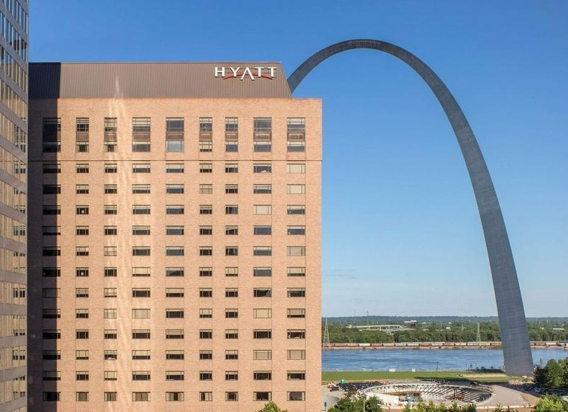

**Where:** Hyatt Regency St. Louis at the Arch, St. Louis MO

**Agenda Outline:**

Monday, July 21, 2025:

* Travel Day and Check In
* ETL Training – limited availability
* Conference Opens with a Welcome Reception

**Get ready for the 15th Annual ASE Instructor Training Conference** – live and in person! Get 20+ hours of technical update training, connect with industry peers, and much more!

Conference Fee:   
$800 for instructors from ASE accredited programs  
$900 for instructors from non-accredited programs  
$500 for family members and industry colleagues

Hyatt Regency:  
$189 per night plus tax

Meals: Most meals during the conference are included.

Tuesday, July 22, 2025:

* Conference Sessions Begin at 8 am
* Sponsor Expo w/ fabulous door prizes!

Wednesday, July 23, 2025:

* Technical Training Sessions Continue
* Networking Event – Budweiser Biergarten

Thursday, July 24, 2025:

* Technical Training Sessions Continue
* Conference Ends at 5 pm

**Scan to add to**

**your calendar**

**Registration is now open at**[**https://www.eventsquid.com/event.cfm?id=27364**](https://www.eventsquid.com/event.cfm?id=27364) **Revised 3/25/2025**