2026 ASE Instructor Training Conference: Sample Justification Letter

Dear <Supervisor’s Name>,
I am requesting approval to attend the 2026 ASE Instructor Training Conference July 20-23, 2026, in Frisco (Dallas), Texas. The conference is presented by the ASE Education Foundation, a non-profit organization that provides accreditation for secondary and post-secondary automobile, truck/diesel, and collision repair programs based on industry-developed standards. The 2026 ASE Instructor Training Conference is the premier national training event focused specifically on the technical training needs of automotive instructors.
At this event I will:
- Have access to 20+ hours of technical update training aligned to my program specialty,
- Connect with other professionals in my role from across the country, as well as industry and workforce experts with knowledge of the latest automotive technology and training trends,
- Learn from other instructors promising practices and lessons used in their classrooms and labs, and
- Gain greater understanding about ways ASE accreditation promotes continuous program improvement.
The conference fee is $<your registration rate here>. Registration includes all educational sessions and keynote addresses during the conference, breakfast and lunch for three days, a welcome reception, a sponsor expo, a networking event, and access to instructors from secondary and post-secondary programs and industry partners from across the country, along with education and workforce vendors. A preliminary agenda is attached.
Here is the breakdown of conference costs:
- Airfare (if flying) -or- Rental Car/Mileage (if driving): <$xxx>
- Ground Transportation and/or Parking: <$xxx>
- Hotel: <$xxx>
- Additional Meals or Per Diem: <$xxx>
- Conference Fee: <$xxx>
Total: <$xxx>
My attendance at this event would bring valuable knowledge and connections back to our school to create a more cohesive, accessible training program for our students and employers in our community. Thank you for your consideration.
Sincerely,
<Your Name here>
Save The Date!
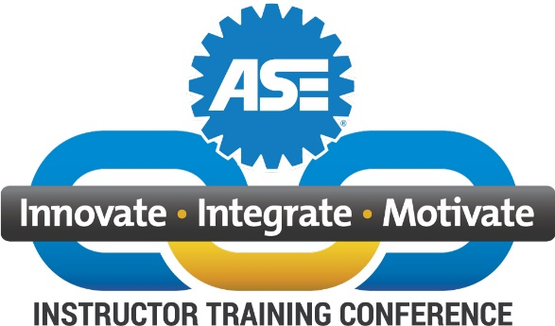
When: July 20 - 23, 2026
Frisco, TX!
July 20-23, 2026
Embassy Suites

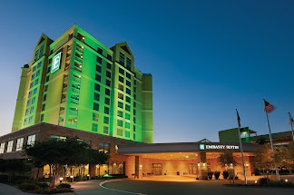
Where: Embassy Suites, Frisco (Dallas), TX
Tentative Agenda:
Monday, July 20, 2026:
- Travel Day
- ETL Training – limited availability
- Conference Opens with a Welcome Reception
Tuesday, July 21, 2026:
Conference Fee:
$825 for instructors from ASE-Accredited programs
$925 for instructors from non-accredited programs
$525 for family members and industry colleagues; Conference Sponsors receive a limited # of passes
Early Bird Special: Register and pay by credit card by Sept. 30, 2025 & save an extra $100 per person
Embassy Suites:
$179 per night plus tax
Meals: Most meals during the conference are included. Breakfast is included if you stay at the Embassy Suites.
- Conference Sessions begin at 8 am
- Training Classes throughout the day
- Sponsor Expo in the evening
Wednesday, July 22, 2026:
- Technical Training Sessions continue
- Networking Event – details TBD
Thursday, July 23, 2026:
- Technical Training Sessions continue
- Conference Ends at 5 pm

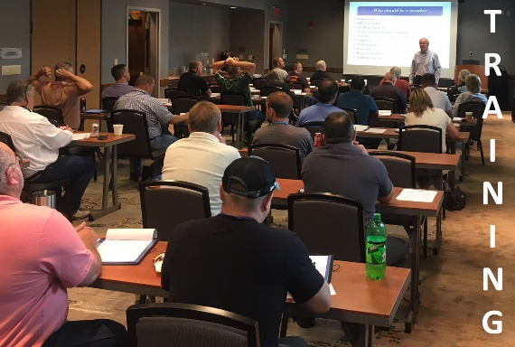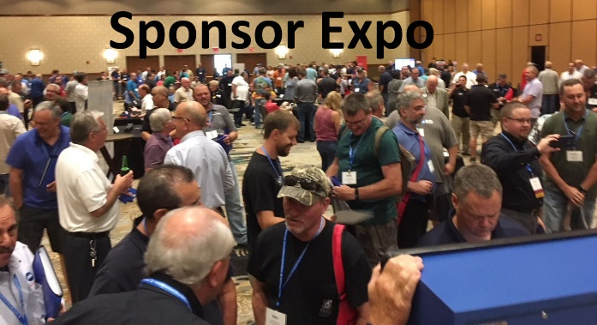
See details and register at
https://www.eventsquid.com/event/29222
Revised 7/23/2025

